**DAILY ONLINE ACTIVITIES SUMMARY**

|  |  |  |  |  |  |  |  |  |
| --- | --- | --- | --- | --- | --- | --- | --- | --- |
| **Date:** | **18/05/2020** | | | | | **Name:** | **Deeksha D Poojary** | |
| **Sem & Sec** | **VIII Semester & A section** | | | | | **USN:** | **4AL16CS026** | |
| **Online Test Summary** | | | | | | | | |
| **Subject** | | **System Modeling & Simulation** | | | | | | |
| **Max. Marks** | | **60** | | **Score** | | | **57** | |
| **Certification Course Summary** | | | | | | | | |
| **Course** | **Introduction to Hadoop** | | | | | | | |
| **Certificate Provider** | | | **Great Learning** | | **Duration** | | | **Two Videos (29 mins)** |
| **Coding Challenges** | | | | | | | | |
| **Problem Statement: Finding frequency of each character in a string & to print the even or odd for the series.** | | | | | | | | |
| **Status: COMPLETED** | | | | | | | | |
| **Uploaded the report in Github** | | | | | **YES** | | | |
| **If yes Repository name** | | | | | **deekshapoojari** | | | |
| **Uploaded the report in slack** | | | | | **YES** | | | |

Online Test Details:

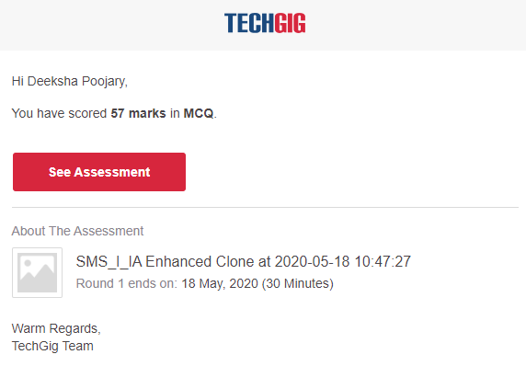

Certification Course Details:

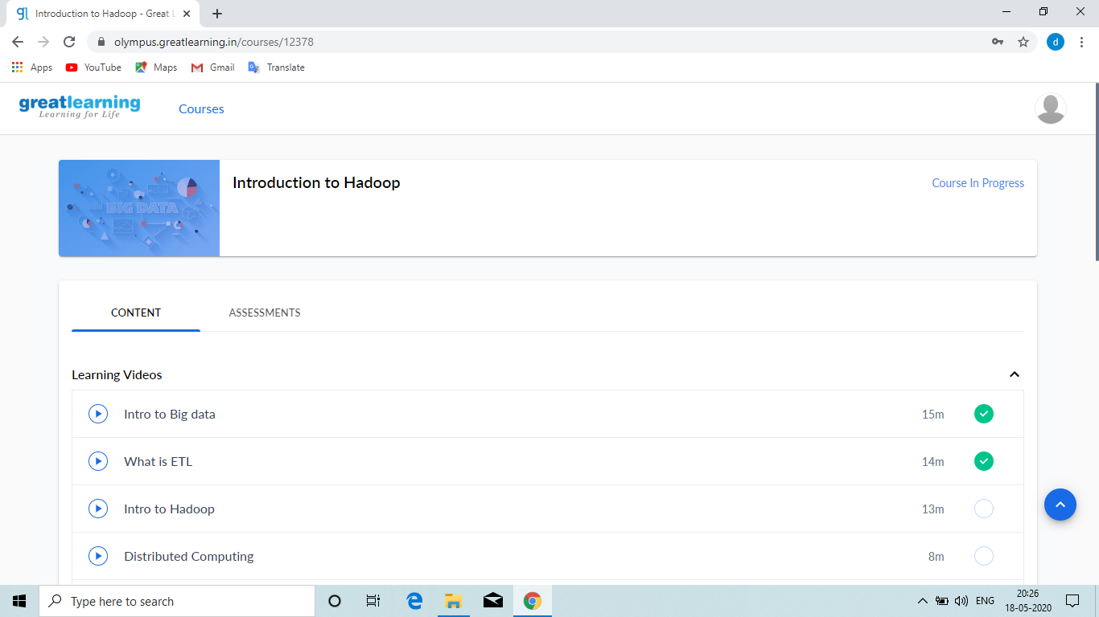

#### Introduction to BigData

Big Data is also **data** but with a **huge size**. Big Data is a term used to describe a collection of data that is huge in volume and yet growing exponentially with time. In short such data is so large and complex that none of the traditional data management tools are able to store it or process it efficiently. For the storage RDBMS s used which stores in table format up to terabyte. To avoid duplication normalization is used.

#### Introduction to ETL

#### Extract Transformation & Load tool is used to get all the information and loaded it to the dataware house and the does transformation as well. It runs on single machine. There is a limit for storing the data in the dataware house. Dataware is very costly affair.

Coding Challenges Details:

**Program no:1**

**package pk;**

**import java.util.Scanner;**

**public class StringOperators**

**{**

**public static void main(String args[])**

**{**

**int i;**

**String str;**

**int counter[] = new int[256];**

**Scanner in = new Scanner(System.in);**

**System.out.print("Enter a String : ");**

**str=in.nextLine();**

**for (i = 0; i < str.length(); i++) {**

**counter[(int) str.charAt(i)]++;**

**}**

**// Print Frequency of characters**

**for (i = 0; i < 256; i++) {**

**if (counter[i] != 0) {**

**System.out.println((char) i + ":-" + counter[i] + " times");**

**}**

**}**

**}**

**}**

**Program no:2**

**public class PingPong extends Thread {**

**static StringBuilder object = new StringBuilder("");**

**public static void main(String[] args) throws InterruptedException {**

**Thread t1 = new PingPong();**

**Thread t2 = new PingPong();**

**t1.setName("\nping");**

**t2.setName(" pong");**

**t1.start();**

**t2.start();**

**}**

**@override**

**public void run() {**

**working();**

**}**

**void working() {**

**while (true) {**

**synchronized (object) {**

**try {**

**System.out.print(Thread.currentThread().getName());**

**object.notify();**

**object.wait();**

**} catch (InterruptedException e) {**

**e.printStackTrace();**

**}**

**}**

**}**

**}**

**}**